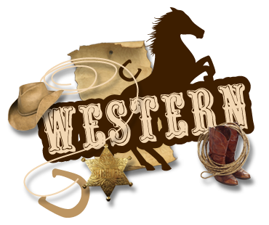
**Saturday August 11th, 8AM sites will reservations for 2019 up until August 11th, 2019 2 reservations per person maximum **
Weekend
At Emmett KOA
August 9-12th
Thursday:
9:00am-8:30pm $Jumping Pillow
1:30-2:00 Arts & Crafts at the Pavilion
2:30-3:30 Mini Golf Tournament meet at store
4:00-4:30 Basketball meet at the court
5:30-6:00 Gaga Ball meet at the Pit
7:00-7:30pm $Ashby’s Ice Cream at the Pavilion
Flipper Snack Bar

Friday:
9:00am-8:30pm $Jumping Pillow
7:00-9:00 Rolling Video Games at the Pavilion (VIP or Visitor wristband required)
8:45 Movie under the stars/ $1 popcorn

Saturday: 9:00am-8:30pm $Jumping Pillow
10:15am Barrel Train ride meet outside the store (VIP or Visitor wristband required)
11:00-11:30 $6 Arts & Crafts at the Pavilion (Color Emmett KOA Pillow Case or Bag purchase by 11:30pm)
2:00-2:30 Western Games at the Playground
3:00-4:00 $Bingo at the Pavilion
7:00-10:00 DJ Dance Party at the Pavilion
Sunday: 9:00-10:30 $ Breakfast at the Pavilion Adults $7/ Children 10-under $4
9:00am-8:30pm $Jumping Pillow
6:00 Barrel Train ride meet outside the store (VIP or Visitor wristband required)
7:00-7:30 $Ashby’s Ice Cream at the Pavilion

*Hunt’s Pizza, Hunt’s Wings & Ashby’s
Ice Cream*
(AT THE PAVILION)

Thursday 5pm-9pm (last pizza/ wing 8:30pm)
Friday 5pm-9pm (last pizza/ wing 8:30pm)
Saturday 12pm-9pm (last pizza/ wing 8:30pm)
Sunday 9am-10:30am (breakfast &
7pm-7:30pm ice cream only)

