- June 17 & 18 Weekend Activities 2022
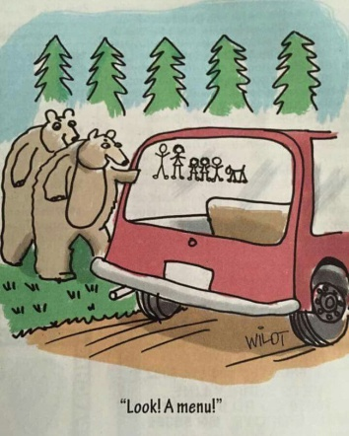
Smoothies and Italian Sodas ALL DAY!
- Pool/Jump Pad open daily from 9am-Dusk
- Buy balloons for Water Wars during office hours ($3/25; $5/50)

Friday, June 17 – Take a Road Trip Day
5:30 pm
    - Barrel Train – Take a ride around our park in our train pulled by our bright yellow golf cart! We’ll pick you up wherever you are! (runs for 30 minutes)
6:00-7:00 pm
    - Scavenger Hunt – Bring a bag for your goodies or we have some and get a prize when you finish!

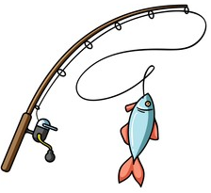
Saturday, June 18 – Go Fishing Day
11:00 am
    - Barrel Train – Take a ride around our park in our train pulled by our bright yellow golf cart! We’ll pick you up wherever you are! (runs for 30 minutes)

1:00 pm - Meet in the Recreation Room
    - Ceramic Painting (available until 4pm) – Come pick a ceramic to paint, from dinosaurs to night lights (small fee applies)
    - Color Time (available until 4pm) – Create your own design or color ours in with special, permanent fabric markers. Fun and easy for ANY age. We have t-shirts, backpacks, bags, and pillow cases. (Cost: $9.99 includes everything)
    - Tie-Dye - Take creativity to the next level and come dye some custom t-shirts, towels, or pillowcases; everything is included! (small fee applies)
3:00 pm
      - Foam Machine and Water Games – A great time to make a mess and have fun! Meet just outside the pool, make sure you don’t forget your swimsuit!
4:30 pm
      - Candy Bar Bingo- bring 1 full-size candy bar for a bingo card (we have some for sale in the store if you don’t have one). If you don’t want candy, you can still play!
- Face Painting – Recreation Room
- Free Crafts – Make your own camp journal or color a wooden keychain!

7:00 pm
      - Office closes: don’t forget to pick up your projects as the office doesn’t open until 1:30pm on Sunday (p.s. If you forget, just call before 10am on Sunday)

8:45 pm
      - Flashlight Candy Hunt – Meet @ the office. Bring a flashlight, bag, and a sweet tooth. Plus, it’s free!

